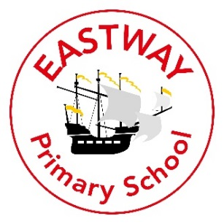

To Children and Parents of Eastway Explorers.
My Name is Mrs Grabe and I am your new Room Lead for 2020/21.
My Role
I am the Two-Year Old Room Lead.
About Me
I am married with two children – Eve who is 12 and Max who is 10. I have lived in Saughall Massie for five years. My childhood home is in Moreton.
Here are a few fun facts about me:
- I have taken part in the Liverpool 10k tunnel run a few times. The first time I did the 10k run I wanted to achieve a finish time of under an hour, I finished in 59 minutes 59 seconds!
- I love spending time with family and friends.
- I have previously (Pre COVID-19) watched my daughter perform twice a year in dance shows.
- My son plays football for Poulton Victoria and has too many trophies to display.
- I love going on long walks with my closet friend of 31 years to chat.
- I was vegan for 3 months for health benefits but could not find a vegan cheese that I liked.
- I have been married for 14 years.
- I met my dad and siblings for the first time 6 years ago. Long lost families inspired me to be brave and ‘just do it’.
- I am an optimist who likes to see the best in people and likes to find the rainbows in every situation.
What you can expect from me
I am patient and considerate of people’s feelings. I am encouraging and love to give praise for great behaviour skills seen. I am a strong communicator who believes that for children to feel empowered and valued they need to develop their communication skills quickly, so they don’t feel frustrated and vulnerable to a lack of self-identity. I encourage children to be nice to each other by sharing, taking turns and speaking about how we feel if we are upset. I am looking forward to an exciting year.

