Behaviour Management
Positive Handling Policy



Spring 2017

Behaviour Management
See also Eastway Primary School Behaviour Policy and Anti Bullying Policy.
Behaviour management is an integral part of the curriculum which teaches appropriate coping mechanisms and relevant social skills to all pupils, thus allowing them to participate fully in the life of their home, school/college and local community.

An individual behaviour management plan may be necessary for a small number of identified children for a variety of reasons, including the following:

- To ensure the safety and well being of that pupil.
- To ensure the safety and well being of members of staff and other pupils.
- To protect the school environment.
- To teach pupils to take responsibility and be accountable for their actions.
- To teach pupils a ‘better way’ or more desirable behaviour.
- To teach pupils that actions and choices have consequences.
- To have a consistent proactive approach to support pupils’ behaviours and emotions.

MULTI-PROFESSIONAL INVOLVEMENT

The small number of pupils who require significant additional support to develop their behaviour will frequently have other services involved with them. Consideration should be given at the outset to who should be alerted and invited to contribute to discussions on how to respond to and manage any challenging behaviours. The school will undertake to coordinate this work.

All professionals and others (family members etc) will be encouraged to contribute and take part in any meetings that are held.

DE-ESCALATION AND DIVERSION

The aim of a de-escalation and/or diversion strategy is for staff to positively intervene at an early stage to prevent a pupil going into crisis.

For examples of appropriate de-escalation strategies see Appendix 4

Help scripts
Help scripts are set phrases which are used at the start, during or after an incident for staff to communicate effectively and calmly with either each other or with the pupil. Help Scripts also establish a consistent language with a pupil during times of support.

Staff to staff help script
It is a sign of professional courtesy to offer help and allow the recipient to choose what sort of help they require. There are some occasions when the member of staff involved is not best placed to make the decision. Other things maybe happening that they are not aware of. This is where the ‘More Help’ script is important.

The words should function like a flashcard.

Offer: “Help is available.....”
Response: “You can help by....”
Offer: “More help.....
Response: “What do you suggest?”

Example:

Offer: “Help is available”
Response: “You can help by getting me a drink for John”.

Or

Offer: “More help....”
Response: “What do you suggest?”
Offer: “I suggest you have a phone call to make and I will help John”.

The person offering help needs to give clear direction and the member of staff can get out with dignity.

Staff to pupil help scripts

If confronted with an incident and having carried out a dynamic risk assessment, it is essential that words are selected carefully. The use of a script can help the member of staff appear calm, ready to listen and does not imply that the pupil is in the wrong, which is likely to have a positive outcome. This also gives the member of staff time to continue assessing the situation and make a plan of action.

Staff: “John…..I can see something has happened....”
Pause for silence
Staff: “I’m here to help....”
Pause for silence
Staff: “You talk and I’ll listen...”
Pause for silence

Ensure that; the pupil’s name is used in order to make them the priority, body language is open, both parties are in social space and give plenty of time for the script to take effect. Repeat if needed.

Staff should also carry out positive listening and learning so that children can develop their emotional literacy skills and learn methods of identifying their emotions and needs and expressing them in a more appropriate manor.

POSITIVE HANDLING

Section 550a of the Education act 1996 and DFEE circular 10/98 allow staff at school who are authorised by the head teacher to use positive handling in circumstances where the pupil may need to be prevented from engaging in behaviours which are likely to cause injury to themselves, others or damage property.

This guidance extends to maintaining good order and discipline for both on and off site activities.

Positive Handling should only be used in circumstances where all other strategies have been tried and found unsuccessful or in an emergency situation. Team Teach Techniques are based on a gradual and graded approach using guides, controls and restraints. Staff must ensure that they select and apply a guide, a control or a restraint that is reasonable, proportionate and necessary and in the best interests of the pupil at all times.
- Guides – Used when there is minimal resistance from the pupil.
- Controls –Used when there is moderate resistance from the pupil.
- Restraints – Used when there is rigorous resistance from the pupil.
There is no legal definition of force. The criminal law act (1967) allows any person to use such force as is reasonable to prevent an offence (e.g. physical assault being committed). Reasonable force must be a matter of personal judgement. All teachers have professional ‘duty of care’ within their jobs which is underwritten in paragraph 58.7 School Teacher Pay and Conditions Document 2009.

This framework is designed to enable two or more staff authorised by the head teacher to use force as they deem reasonable in order to prevent pupils from:
- Committing an offence
- Causing personal injury to, or damage to the property of, any person (including the pupil himself)
- Engaging in a behaviour which is prejudicial to the maintenance of good order and discipline of the school or among its pupils, whether it is during a teaching session or otherwise.

RESTRICTIVE PHYSICAL INTERVENTION

Restrictive Physical Intervention (RPI) is the positive application of force with the intention of protecting the pupil from harming themselves or others or seriously damaging property.

The proper use of Restrictive Physical Intervention requires skill and judgement as well as knowledge of the agreed methods of positive handling that are appropriate to the individual.

The decision to use restrictive physical intervention must take account of:
- In the best interests of the pupil – taking into account all the relevant circumstances
- Must only employ a reasonable amount of force
- Must be proportionate to the circumstance
- Must be necessary - based on an assessment of risks associated with intervention compared with the risks of not employing physical intervention.
- Medication/illness
- Physical disabilities
- Sensory impairments

If at ANY point during RPI staff become unsure of the pupil’s breathing (including the pupil stating that they cannot breath) or feel that their medical situation has changed, staff MUST take IMMEDIATE ACTION and either release the pupil or modify the hold. This provides an opportunity to improve breathing or to re-engage if needed. This should be recorded and reported following the correct procedures.

POSITIVE LISTENING AND LEARNING

Positive Listening and Learning is a separate part of the process aimed at rebuilding relationships and making things better for the future.
- Formal debriefing. Staff and/or pupils complete form.
- A copy should be kept in the pupil’s file.
- Formal or Informal ‘chat’ between staff and pupil
- Relationship rebuilding
- Formal/informal discussion between staff involved regarding how the incident was managed and what to change next time in order to teach a better way. Refer to de-escalation and distraction strategies.

When carrying out Positive Listening and Learning it is important that the following factors are taken into consideration;
- TIME: There can be no hard and fast rule about choosing the right time. Listening and learning can only begin when the pupil is ready. It cannot be forced. Staff should ensure that there is sufficient time for the process so that it will not feel rushed.
- ENVIRONMENT: The choice of environment should be a comfortable and neutral area where you will not be disturbed. Staff should try to ensure seating is at the same height and there are no artificial barriers.
- LISTEN: Part of active listening involves looking at body language and trying to establish rapport – “listen with your eyes”. Listening should be non-judgemental to obtain the fullest appreciation of the pupils account of what has happened. A member of staff can then help the pupil to learn from that incident.
When using the de-briefing cards the structure and purpose remains the same following the acronym of HELP.
H: Hear the individuals’ story first and try to listen to the feelings as well as the words.
E: Explain why the member of staff had to take the actions they did. Use “I” language to explain that we have a duty of care to keep people and property safe, why the actions were in the pupils’ ultimate best interests.
L: Link the feelings of the pupil with the behaviour. Separate the person from the behaviour.
P: Plan together to find a better way of dealing with similar emotions in the future. What can both staff and pupils do differently to reduce the chance of repetition?
Examples of debriefing resources can be found in Appendix 3.

ASSESSING, RECORDING AND REPORTING

Individual Behaviour Management Plans
The purpose of a Behaviour Management Plan (Appendix 2) is to communicate the best strategies for the individual to help them deal with their behaviours, emotions and sensory needs in a consistent, safe and appropriate manner.

The plan indicates what a pupil looks like when they are calm and ready to learn. When they are happy and excited. The Behaviour Management Plan paints a picture of what the pupil looks like during stages 1- 5 and what staff should do to respond in order to offer support that is reasonable, proportionate and necessary and in the best interests of the pupil at all times.

The Behaviour Management plan also contains information with regards to medical and communication factors in order to carryout debriefing that is at a suitable level of understanding for the pupil. The plan has suggested physical restrictive intervention techniques that should be tried or avoided to suit the individual.

The plan also includes targets that should be realistic and meaningful for the pupil. The achievement of these targets can help to demonstrate progress.

Parents/carers are encouraged to suggest strategies to complete these plans to adopt a consistent approach to addressing the pupil’s behaviour. All up to date behaviour management plans should be signed by a parent or carer where appropriate.

Positive Handling Record
Any incidents that require the use of restrictive physical intervention MUST be recorded on Positive Handling Record. (Appendix 1).

Communicating with Parents/Carers
As well as the Behaviour Management Plan being communicated with parents/carers, it is good practice that the use of any restrictive physical intervention is communicated on the day it occurred.

Injuries to staff, pupils and others
“Team-Teach techniques seek to avoid injury to the service user, but it is possible that bruising or scratching may occur accidentally, and these are not to be seen necessarily as a failure of professional technique, but a regrettable and infrequent side effect of ensuring that the service user remains safe”. (George Matthews - Director)

If a member of staff is injured during an incident then they should leave the incident as soon as is safe to do so to seek medical advice from a first aider. A first aider will complete a medical form. The injured member of staff must also complete an accident at work form and get it signed by the Health and Safety officer. A copy of this form must be obtained by the injured member of staff and a copy placed in the pupil’s file who inflicted the injury. It is the decision of the Headteacher or Senior Leadership Team and the injured member of staff as to whether or not the injured member of staff is fit to continue to fulfil their job requirements for the day.

If the pupil themselves gets injured whether it be during restrictive physical intervention or from self-injurious behaviour completes an accident form and inform parents.

If a pupil is injured by another pupil; complete an accident form and inform parents of injured pupil and the parents of the pupil who caused the injury if necessary.

If a staff member gets injured by a pupil or during an incident; complete an accident form.

APPENDICES

- Parent letter

- Positive Handling Record

- Positive Behaviour Management Plan

- Examples of De-briefing cards

- Examples of De-escalation and Diversion Strategies

Appendix 1

The use of Positive Handling to manage
Physically challenging behaviour’

Physical Contact / Physical Intervention

I understand that I will be informed each time a physical restraint has been needed to defuse challenging behaviour. I understand this may be used to divert my child from a destructive or disruptive action, for example guiding or leading a pupil by the hand, arm or shoulder with little or no force.
This will involve the use of reasonable force when there is an immediate risk to pupils, staff or property. It is important to note that the use of ‘reasonable force’ should be seen as a last resort. All such incidents must be recorded and available for me to access at anytime.

I have received a copy of Eastway’s Positive Handling Policy.

Name of child:

Class:

Name of Parent/ Guardian:

Signature:

Date:

Eastway Primary School
Appendix 2
POSITIVE HANDLING RECORD

Date: |  | Time:
Members of Staff |  |  | Child’s Name
Details of incident

Name and Signature of Parent

Name and Signature of Staff

Name and Signature of Headteacher/SLT

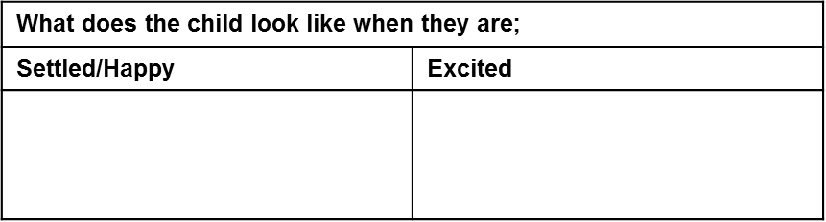
Positive Behaviour Management Plan
Child’s Name:
Date of Plan:
Review Date of Plan:________________________
Appendix 3
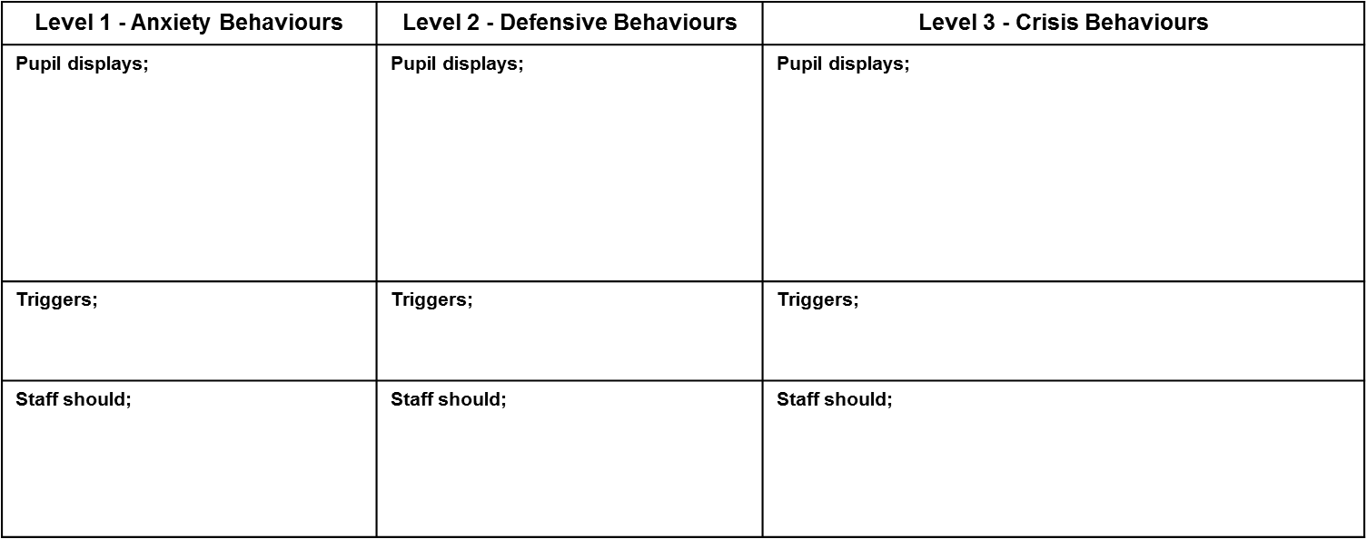
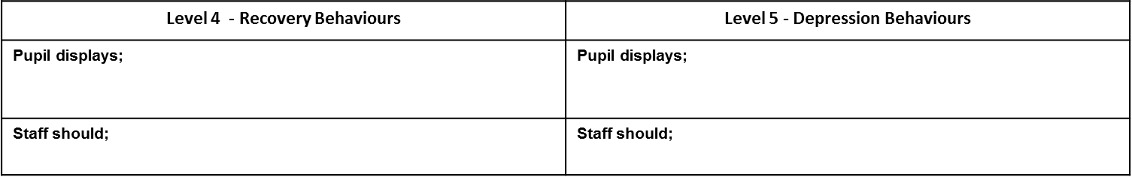
Child’s Stages of Behaviour

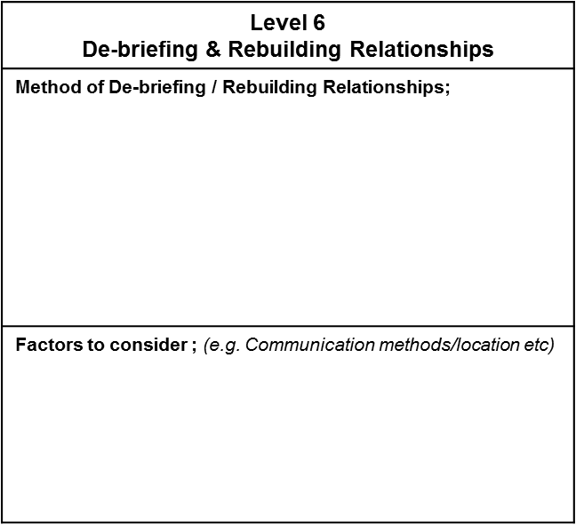
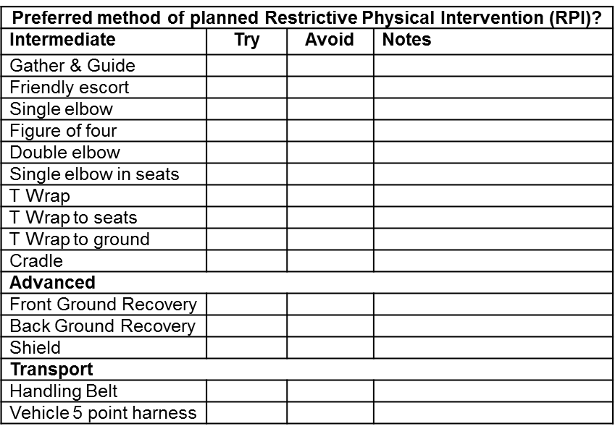
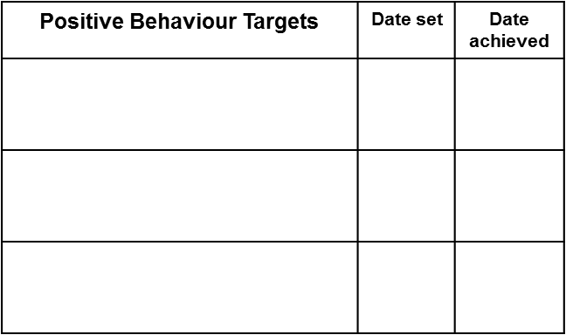
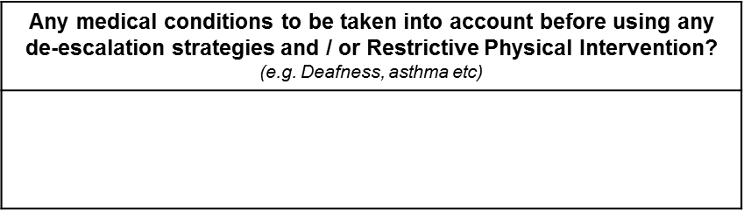
On signing this document you are agreeing to the procedures and strategies being used to address your son/daughters behaviours.

Signing: __________________________ Date: ______________
(parent / guardian)

Signing: __________________________ Date: ______________
(on behalf of the school)

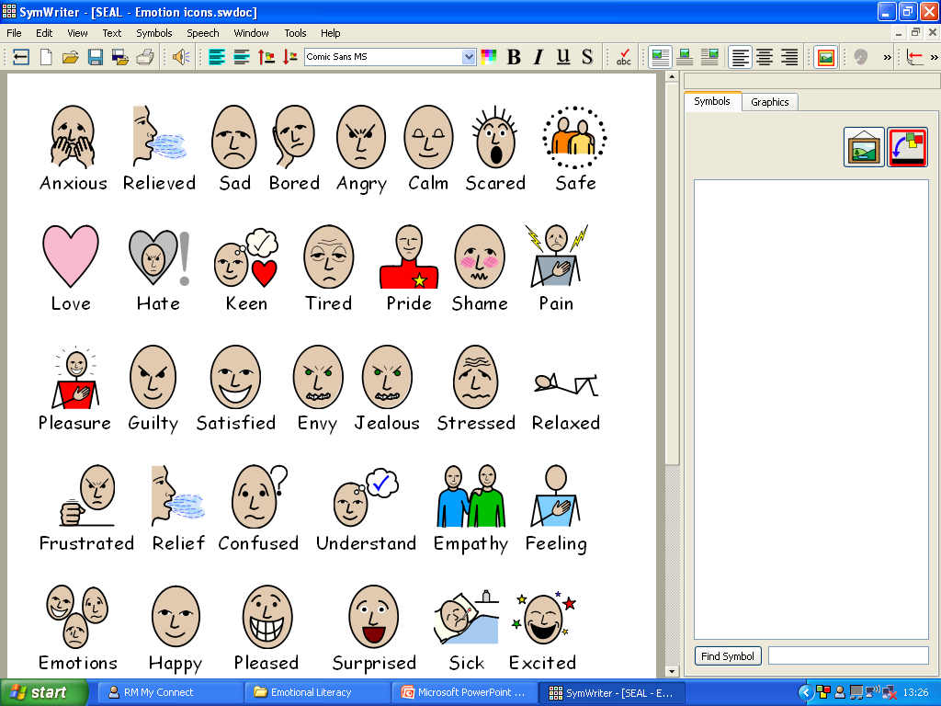
Comic strip!
Appendix 4
Me
This happened....
I felt....
If I feel like this again I will....
Pupil:______________________________
Staff:_____________________________
Date:______________________________

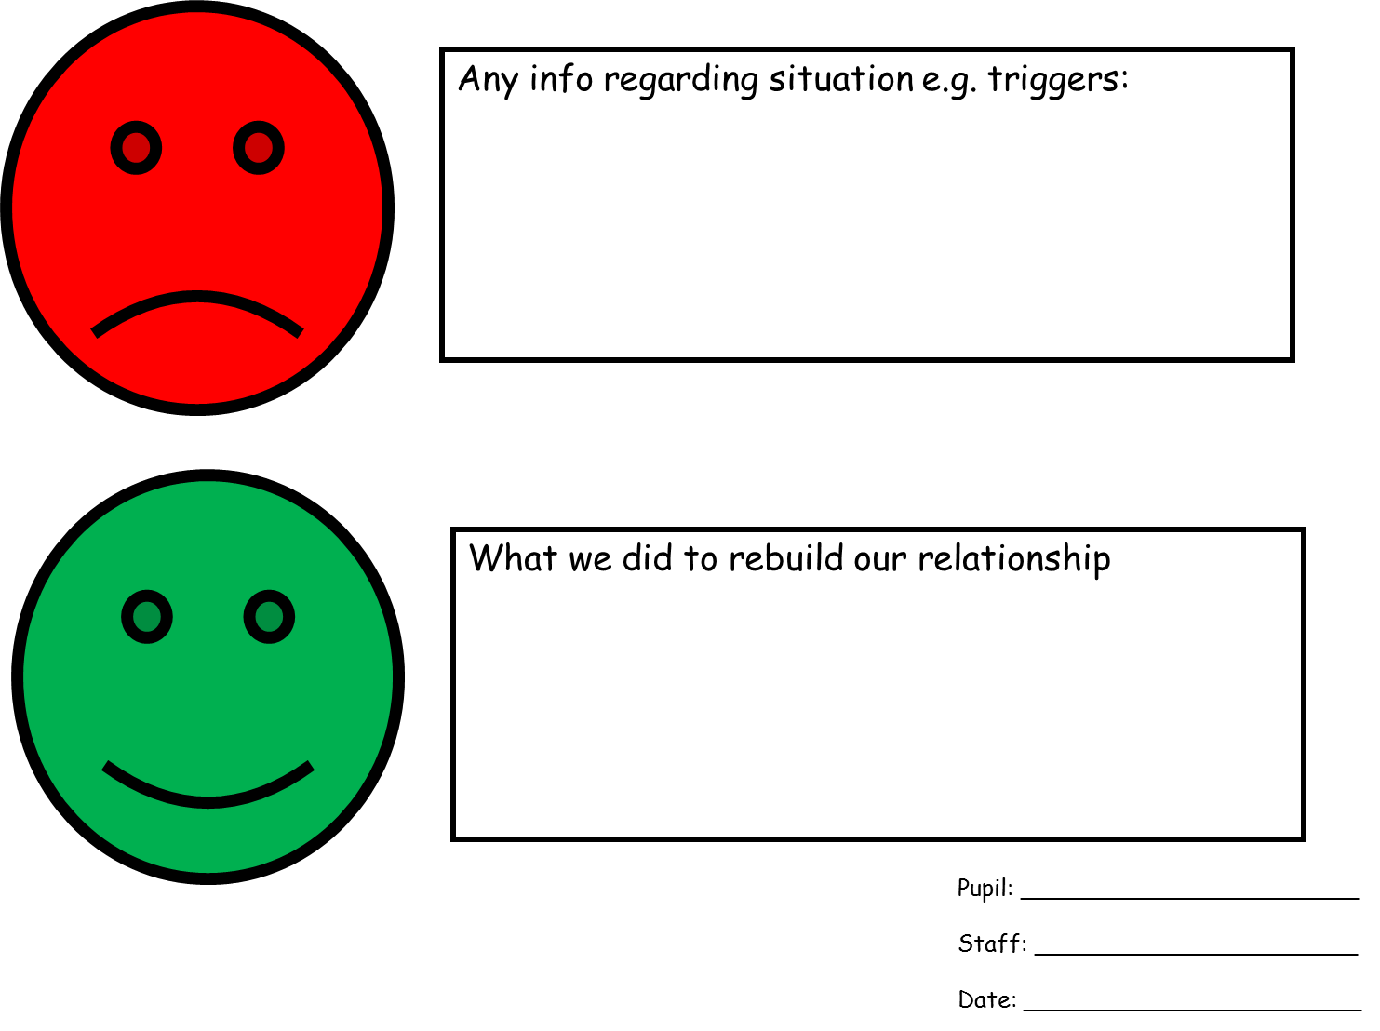
Examples of de-escalation and diversion strategies
Appendix 5
De-escalation strategies may include;
- Change of environment (pupils may ‘go on a job’)
- Change of face (a different/new member of staff deals with the situation but remains in line with the pupil’s Behaviour Management Plan)
- Change in tone of voice
- Change in body language, calm stance and posture
- Humour
- Model desired behaviour
- Build in routines
- Doing something unusual
- Give freedom
- Remind of consequences
- Remind of rules and responsibilities
- Give empathy (not patronise)
- Engineer success / praise
- Change noise / light / scent levels
- Change activity
- Remove the audience
- Use private, understood signals
- Use powerful pauses / silence
- Take up time
- Use help scripts
- Photos / happy book/ Toys / Objects
- Count down or up (use timers if needed)
- Communicating with pupil using careful use of language
- Physical support (being held in this instance is not RPI)
- Sensory Diet (see Michelle)
- Intensive interaction
- Massage (refer to Aromatherapy and Massage Policy)
- Mirrors
- Drink / food
- Medication
- Body position of pupil
- Make a deal cards/Working for cards/ waiting for cards

