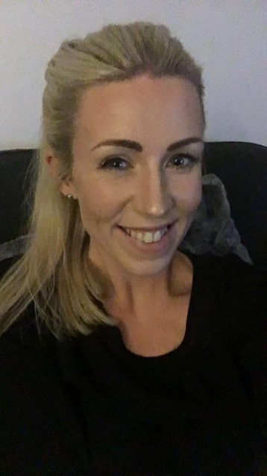
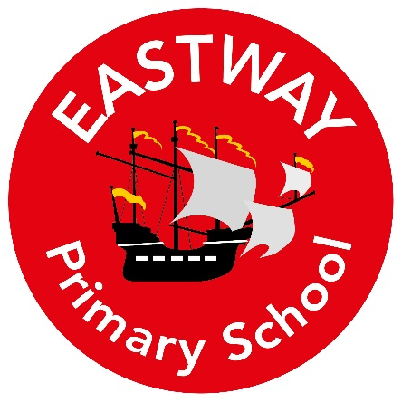

To Children and Parents of Year 1,
My Name is Mrs Billington and I am your new class teacher for 2019/2020.

My Roles and Responsibilities
- Year 1 class teacher
- Physical Education and Wellbeing Lead
- Art and DT lead

About Me
I have taught in schools on the Wirral, in Ellesmere Port and also internationally in Spain. I qualified with an Early Years specialism as part of my teaching degree and over the past 10 years I have taught between the Foundation Stage and Key Stage One.
In my spare time, I like to travel and spend many of my holidays exploring new and exciting places. I enjoy cooking and often host my own ‘Come dine with me’ with my friends. I like being in the great outdoors and spend a lot of time walking and camping.
Here are a few fun facts about me:
- I have a pet tortoise called Melton.
- My nickname in school was ‘beetroot’ as I have very rosy cheeks.
- I have one younger brother called Ross
- When I was younger I wanted to be a ‘Red coat’ at Butlins

What you can expect from me
I will share stories I have read with you, ask you about the stories you have read at home and share special stories in class with you too! I will make sure that you are progressing in your learning and encourage you to always try your hardest.

I am looking forward to joining the school in September.
Have a wonderful Summer break!

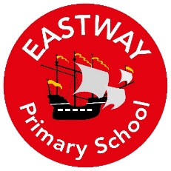
Summer Home Learning
Reading- Summer Reading Challenge
Go to your local Library and take part in the Summer Reading challenge. Once you have completed it bring it into school in September to celebrate with the class.

Maths- Number bonds
In Year 1 we learn our number bonds to 20. You can get a head start by using the website below to begin practising your fast recall of number bonds.
https://www.topmarks.co.uk/maths-games/hit-the-button

DON’T FORGET OUR ’30 THINGS EVERY CHILD SHOULD DO BEFORE THEY LEAVE EASTWAY’ challenge. You may like to cross a few of these off this summer.

