Dear Eastway families,

The children in Year One have been working really hard in their phonics screening checks. Mrs Brown commended all the children and staff for all their work in making this such a successful year for reading in KS1. The Year Four children have also been busy with their multiplication checks- we are very proud of them for all their efforts! Mr Saunderson, our maths lead teacher, was ecstatic with all their hard work and the improvement every child has shown this year with their times tables. Here’s what else has been going on this week. Have a lovely weekend!
Mrs Benson

Explorers | 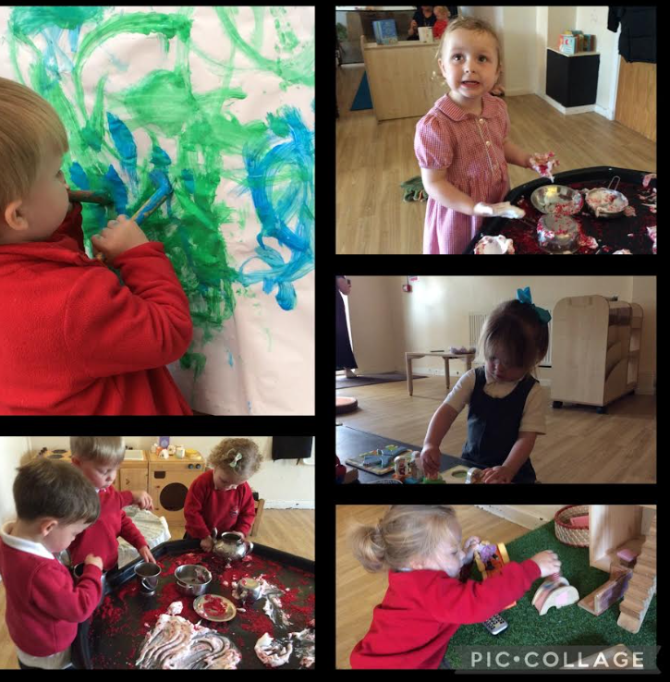  A little snapshot of Explorers, using their clever hands to paint, build and explore.
Nursery | 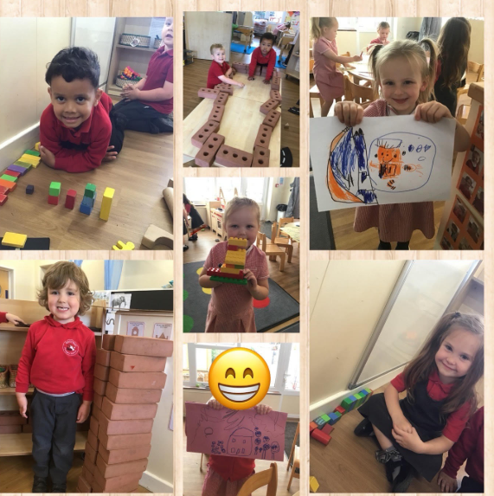  We are designers! Look at our creativity this week- draw, review, build!
Reception | This week the children have been enrolled in our SUPERHERO TRAINING ACADEMY. We trained to be superheroes in PE (check out Twitter/ X for pictures), created our own capes, came up with our own superhero names and even dressed up like superheroes! In maths, we used our super skills to investigate 3D shapes!
Lunar | The children engaged in a variety of tactile play, walking barefoot over different textures to stimulate their senses. They delighted in the crackle of bubble wrap beneath their feet and the natural feel of materials such as leaves, grass, soil, and water. These activities encouraged curiosity and supported sensory development, allowing the children to connect more deeply with the natural world—just like the animals we’ve been learning about.  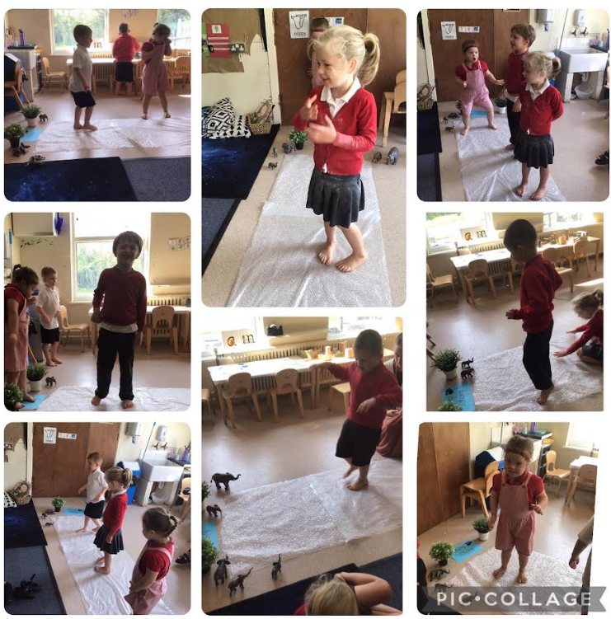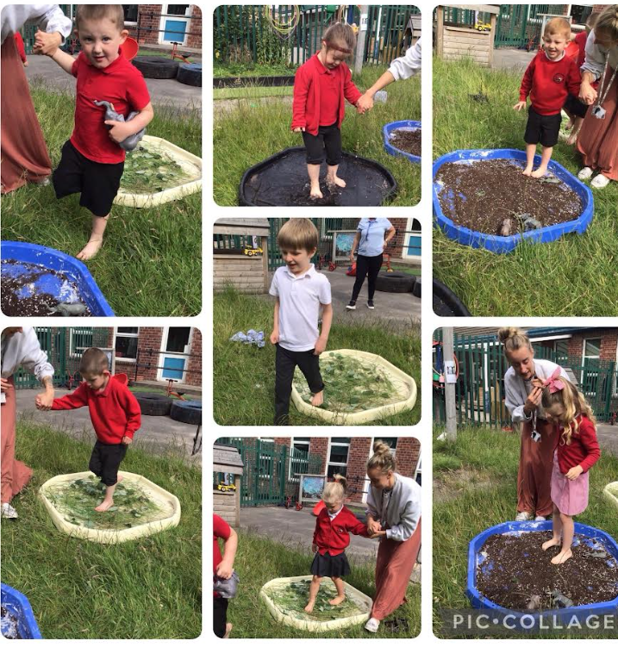
Year 1 | Year One Phonics Screening Success!  This week, Year One took part in the Phonics Screening Check, and we couldn’t be prouder of all their hard work and determination! To celebrate their fantastic efforts, Miss Goddard organised a special treat during Golden Time—our classroom was transformed into a cinema, complete with popcorn, treats, and even face painting! Well done, Year One! We are incredibly proud of each and every one of you.
Year 2 | Year 2 have had a super busy week. In Science we have continued our learning all about seeds. This week we dissected seeds and found out that seeds have their own food store and seed coat to protect them before they germinate.  We have also been completing our assessments and everyone has worked extremely hard. We have had a mini celebration today to celebrate all our hard work and achievements- pictures to follow next week.
Apollo | This week Apollo have been reading Supertato, we have enjoyed making the characters out of real vegetables to help us retell the story. In expressive art the children used water colours to paint different fruit and vegetables and enjoyed chopping them up to explore their texture and shape. Finally we have been learning about how we can keep ourselves healthy.
Year 3 | 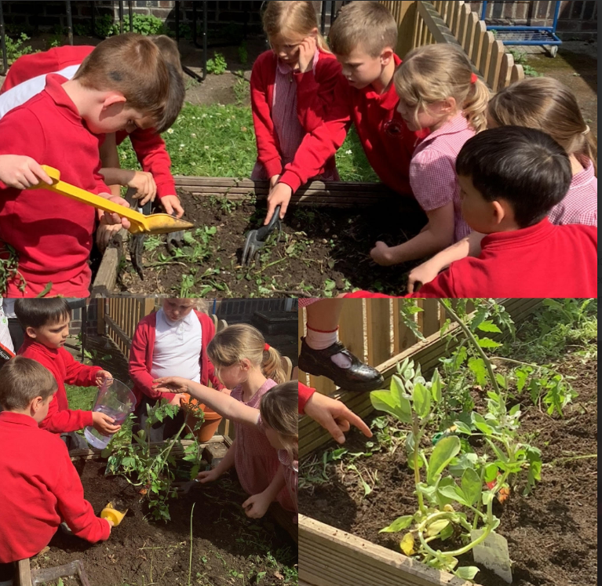  It’s been another action packed week in Year 3! We’ve been budding botanists, checking in on our new class plants and learning all about how they work. In geography, we’ve dug into the Earth’s structure. Don’t worry, no volcanoes erupted in class (just a few mind blown moments!). In PSHE, we celebrated everyone’s unique strengths, while in maths we’ve been solving time problems. Turns out, time really does fly when you’re having fun. English has us debating the use of palm oil, using contrasting conjunctions and formal language. To top it all off, we danced our way into the weekend with big smiles and some seriously cool moves!
Year 4 | 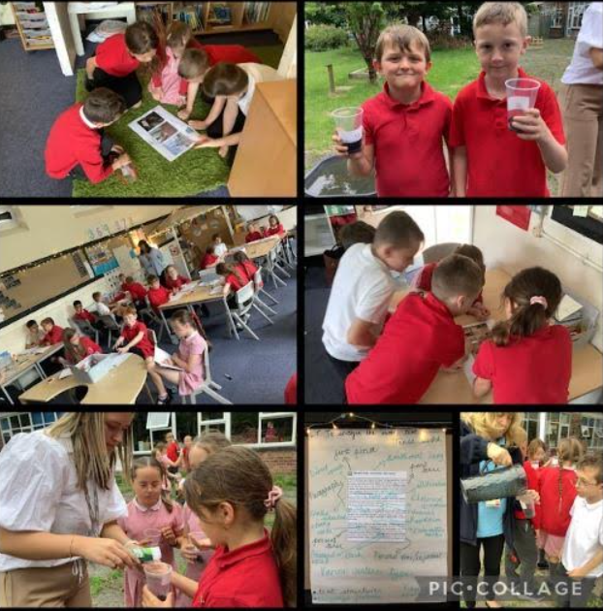  It has been a big week for Year 4 as we've been completing our MTCs. We have been working exceptionally hard for the past few months and our teacher is extremely proud of us, she couldn't have asked us for any better! We have been playing lots of times table bingo and winning lots of prizes. In science, we've been planting seeds and we are excited to observe the water cycle in action. We have had a big afternoon of celebrating today for all our hard work.  .
Discovery | This week in Discovery, we've been learning to recognise three-quarters in maths and continued to write non-chronological reports in English. In science, we explored the difference between bulbs and seeds, and in geography, we described the location of Mugurameno village. In DT, we safely used saws to create wheels for our beach buggies.
Year 5 | 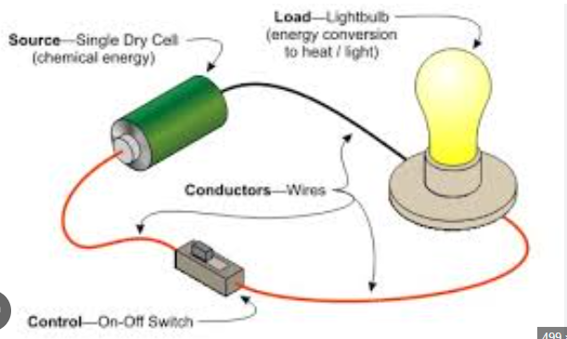  Year Five have been busy in science making electrical circuits. They also learned about online safety with our Police Community Support Officers.
Year 6 | Year 5 and 6 had a lovely visit from our Police Community Support Officers this week, who talked about the importance of keeping ourselves safe online. Some children spoke about how they would love to join the Police force in the future!  Year 6 will be running an assembly for Year 1 and 2 next week to share what they learnt during the afternoon. They have been working hard to perfect their assembly power points in preparation!
Enterprise | This week, Enterprise have been calculating with money and will be applying this to real-life scenarios. Soon, we will be reading time using a traditional clock. It would be really helpful if you could help at home with this by using as many opportunities as possible to familiarise your child with clocks at home and not just digital ones on tablets and computers. Thank you

Reminders

- Reminder- Year 6 parents to meet in school, via the usual KS2 gate at 9.15am on Monday (16th) to discuss the prom.
- If you have any type of concern regarding your child, please always use the class emails for first line of communication.

- KS1 playground- We request on health and safety grounds that no children use the playground equipment after school.

Golden pupils  Last week’s golden pupils were…  Reception Jacob  Year 1 Leo  Year 2 Darcie  Year 3 Austin  Year 4 Tyler  Year 5 Theo  Year 6 Abby  Apollo Jake  Discovery Riley  Enterprise Evan  Congratulations to them all! | The class with the best attendance in the last week of term was…  Year 1 with 99.4 % 

