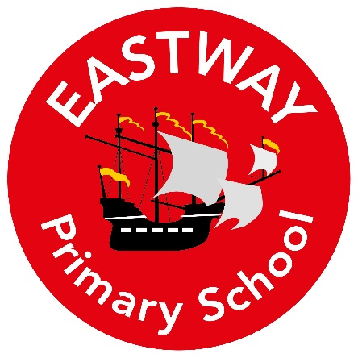

To Children and Parents of Year 6
My Name is Mrs Hancock and I am your new class teacher for 2021/2022.
My Roles and Responsibilities
- I teach Year 6
- Reading subject leader.
About Me
Here are a few fun facts about me:
- My favourite colour is grey,
- I love to exercise and go to the gym,
- Spending time with my family is very important to me,
- My favourite foods are pizza, cheese and chocolate,
- I have always wanted to be a teacher,
- You never know when a prize is coming!
- I have two children; Louis and Freddie
- I am a morning person,
- I am extremely random,
- I support Liverpool F.C,
- I think it is important to always be kind,
- I love seeing people smile and laugh.

What you can expect from me

I am so excited to begin my Eastway Primary School journey with you in Year 6. I’m looking forward to getting to know each one of you and help you through your final year in Primary school. Year 6 is a year that you will always remember- I can still remember mine! There will be lots of hard work involved but also a lot of fun.
I always have my nose in a book and would love to hear any recommendations you might have. Therefore, if you read any exciting things over the holidays- be sure to let me know!
I hope you have a fantastic holiday and have plenty of rest to make sure you are firing on all cylinders in September. I just cannot wait for our adventure to begin.

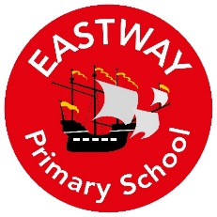
Summer Home Learning
Reading- Summer Reading Challenge
Go to your local Library and take part in the Summer Reading challenge. Once you have completed it bring it into school in September to celebrate with the class. See below for details:
Wirral Libraries and The Reading Agency are delighted to present the 2019 Summer Reading Challenge: Space Chase - celebrating the 50th anniversary of the moon landings.
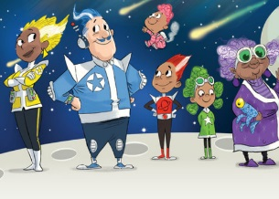
The Summer Reading Challenge takes place every summer holiday. You can sign up at your local library from Saturday 13 July (ends 31 August), then read at least six library books of your choice over 4 visits (minimum 2 books per visit) to collect special stickers and other incentives along the way – all free. All participants will receive a certificate and for those that complete the challenge a medal and certificate will be awarded.
Maths- Times Tables
It would be really useful if you knew all of your times tables in September. So any opportunity you get (in the bath, on the toilet, at the dining table) make sure you’re getting lots of practise. Here are a few websites that will help you too:
- https://www.topmarks.co.uk/maths-games/hit-the-button
- http://www.bbc.co.uk/skillswise/game/ma13tabl-game-tables-grid-find

Topic Homework
Research any explorer that interests you. You could include:
- Maps of their journeys
- Important discoveries
- A biography
- How they’ve inspired you.
- Portraits

Please ask the school if you need paper to complete this task.

Please bring your work with you on the first day of Year 6. We can’t wait to see your work!
Mrs Hancock and Miss Coverdale

