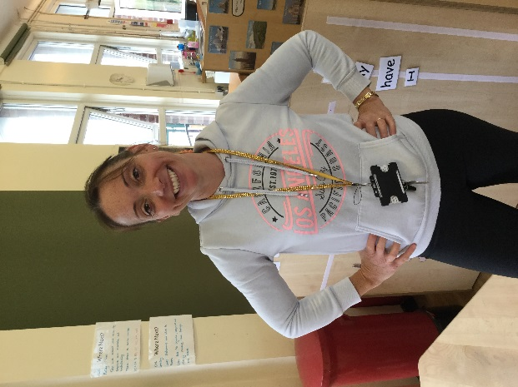+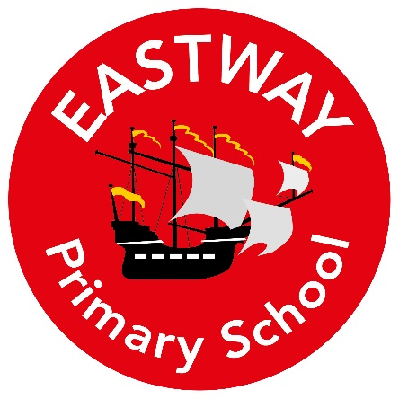

To Children and Parents of Reception

My Name is Mrs Holmes and I am your new class teacher for 2020/21. I will teach you on a Thursday and Friday.

**My Roles and Responsibilities**

I am a Reception class teacher and I am responsible for Music across the school.

**About Me**

I am married with three children – Sophie, Evie and Kieran. I love being a mum and a teacher! Here are a few more things that I enjoy:

* I love animals especially rabbits.
* I enjoy spending time with my family especially when we go for countryside walks with our dog Toby.
* To keep fit I like to go swimming.
* I love to sing!
* My favourite colour is blue.
* I enjoy going to musical shows at the theatre.
* I love chocolate!

**What you can expect from me**

I love teaching and will help you to learn by having lots of fun. We will learn through playing with items that you find interesting. We will sing lots of songs and create lots of fabulous creations. I am firm but fair and I will always encourage you to do your very best. I love to tell stories and use puppets to bring them to life. I hope you will have a fantastic time in Reception. I am looking forward to fantastic year ahead of us!